What is World Oceans Day?
The United Nations celebrates World Oceans Day every year on 8 June. Many countries have celebrated this special day since 1992, following the United Nations Conference on Environment and Development, held in Rio de Janeiro.
In 2008, the United Nations General Assembly decided that, as of 2009, 8 June would be designated by the United Nations as “World Oceans Day”.
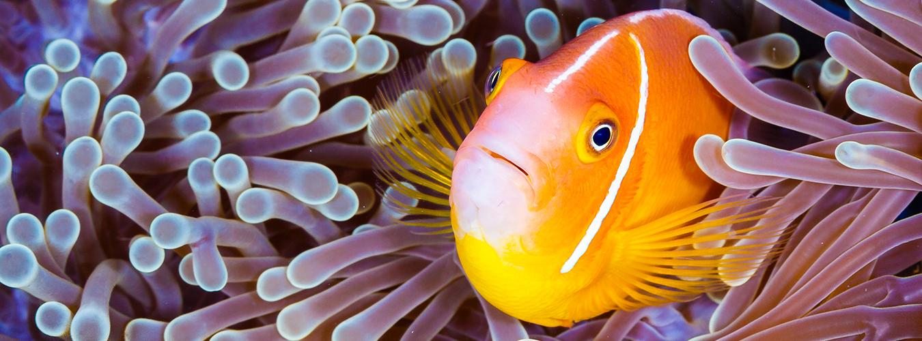

Grant Thomas / Coral Reef Image Bank.
Every 8 June, we have an opportunity to raise global awareness of the benefits humankind derives from the ocean and our individual and collective duty to use its resources sustainably. Future generations will also depend on the ocean for their livelihoods!
Aquariums, science centers and research institutions, NGOs, communities and governments all around the world mobilize millions of people around events big and small. This is your portal to finding which events are happening around the world and in your neighborhood.
Together with the United Nations Family and our partners, let’s celebrate all that the ocean gives us every day: from the oxygen we breathe to the inspiration that moves our poets.

Our Ocean is Our Future

Oceans feed us, regulate our climate, and generate most of the oxygen we breathe. But despite their importance, oceans are facing unprecedented threats as a result of human activity.

